1.
The core meta loop revolves around raising your daughter from childhood to adulthood and shaping her personality. As the player, you decide on aspects such as her relationships, studies, and skill development. By managing her monthly schedule, you foster her growth and ultimately guide her toward her own unique ending.
The macro loop supports your daughter's growth across different age stages. You take her out for activities at age five, while for the 12–17 age range, you organize monthly study plans and allow her to go on an adventure at the end of the month. Additionally, various story events are triggered each month based on her experiences while out and about.
In the monthly planning within the study system, coursework accounts for the largest share of the schedule. My daughter enhances her abilities by taking various courses; completing them not only boosts her stat values ​​but also earns her gold coin rewards.
Regarding the economic system, the primary currency in Volcano Princess is gold coins. Players mainly earn them by having the daughter work over set periods; she can also choose to take on part-time jobs to earn gold while adventuring at the end of the month. Gold coins can be used to purchase activities and items that boost the daughter's stats, as well as to buy weapons and fund outings with friends.
The combat system is another important system in the micro-loop. It primarily takes place during the expeditions at the end of each month, offering substantial rewards alongside significant risks. The daughter can choose to venture out with friends for combat-oriented expeditions. The battles are turn-based, with players gaining skill points each turn to unleash abilities—though each character is limited to using a skill once per round. Various battles and events are triggered throughout the course of an expedition.

2. I believe the creator of Volcano Princess wanted players to experience a sense of accomplishment and pride—specifically, the satisfaction of watching their daughter grow increasingly capable under their guidance. While this feeling certainly arises during gameplay, there is sometimes ambiguity regarding the perspective from which we assist her; within the game world, the father does not participate in her activities once she is older, yet the player guides her from what feels like a third-person perspective.

3. This game can essentially be played using only the mouse; there are no options for other controllers. Virtually all functions and interactions involve on-screen buttons that respond to the mouse cursor. The spacebar can be used for certain actions, such as skipping story dialogue. These can also be performed via mouse clicks.

I find this style of interaction quite comfortable. Like other games that focus on narrative and mini-games, the design prioritizes mouse input over the keyboard. You can navigate and explore using the mouse, and even the mini-games are playable through mouse clicks. I believe this mouse-driven control scheme makes the game very easy to pick up, so there is little need for improvement—though perhaps increasing the utility of the keyboard could be an option. Furthermore, *Volcano Princess* lacks a key-binding menu simply because there are hardly any keyboard controls to begin with.

4.
Opening menu(shown in Figure 1): The UI design is minimalist, featuring only a single image, a few control buttons, and falling flower and star motifs. The imagery depicts a man cradling an infant, sparking player curiosity about the connection between the visual and the game itself. Meanwhile, the background and musical tone are somber, creating a subtle contrast with the visuals.
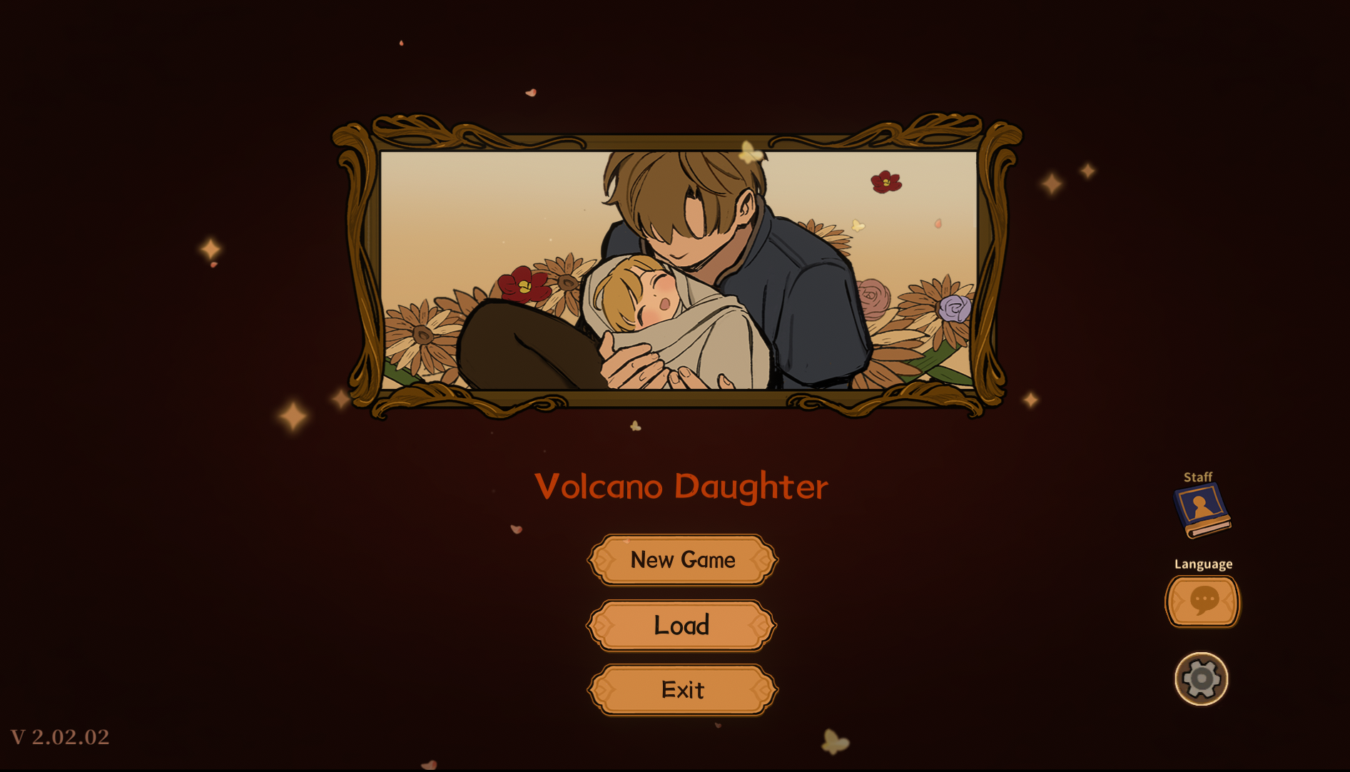
(Figure 1: Opening menu for Volcano Princess)

In-game menus(shown in Figure 2): The UI is also very clean and minimalist. Key bindings are displayed on the left. As previously mentioned, the game is primarily mouse-controlled, making the central settings easily accessible and interactive via the mouse. The menu includes standard options—such as volume control and save/quit functions—allowing players to adjust game settings. The UI features a brown color scheme reminiscent of a traditional wooden cabin, evoking an atmosphere of learning—which aligns with the game's core theme of the daughter's education.
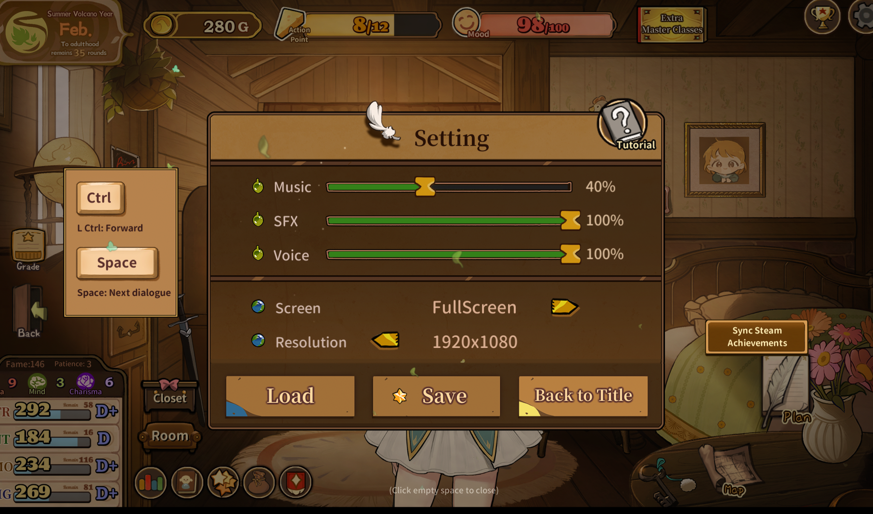
(Figure 2: In-game menu for Volcano Princess)

Normal gameplay UI(shown in Figure 3): The UI typically displays various details regarding the daughter's status—such as her stamina and mood at the top—along with her attribute stats in the bottom-left corner and various interactive buttons. The entire interface is set against the backdrop of the daughter's bedroom. Notably absent from this UI is any information regarding the player's own avatar or status as the father. Certain in-game achievements appear here but serve no functional purpose, effectively acting as irrelevant information.

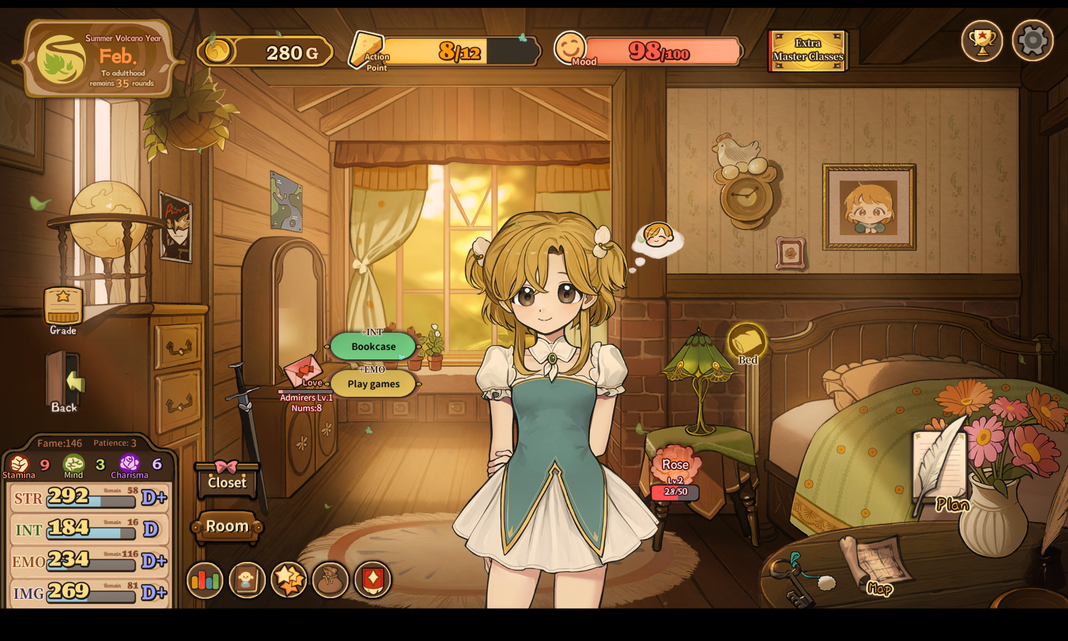
(Figure 3: Normal gameplay UI for Volcano Princess)

